LWCF Boundary Map Checklist

Revised 7.28.2026
Provide the following required information on the LWCF BOUNDARY MAP. An example can be found on page 4 and 5.
- Title of Map: Use the following title formula at the top of the LWCF BOUNDARY MAP:
“LWCF Boundary Map for [name of PARK], [name of APPLICANT], LWCF project number [number provided by OGALS if APPLICATION is successful], in the county of [name of COUNTY]."
- LWCF Boundary:
  - Show the boundary of land placed under LWCF protection. Use red as the color indicator to show this boundary.
  - Choose a scale to use and show it on the LWCF BOUNDARY MAP as one inch = (scale length chosen) for maps for areas of larger size. Or, provide the linear feet measure alongside each boundary line. The entire PARK must be placed under LWCF protection.
- Previous LWCF Protected Acreage (if applicable):
  - Show the boundary(ies) of the land previously placed under LWCF protection. Use blue as the color indicator to show this boundary.
  - Within the boundary, indicate the acreage previously placed under LWCF protection and the project number for the previous LWCF project(s).
  - Include a statement in the map key that READS “## acres were placed under LWCF protection in [YEAR] because of [PROJECT NAME(S)] project [06-XXXXX].” List all LWCF project names and numbers as applicable.
  - If you are unsure if your park has previously received funding from LWCF, contact the NPS Unit Project Officer assigned to your county.
- Assessor Parcel Numbers:
  - Show the Assessor Parcel Number(s) and the acreage for each parcel within the red LWCF BOUNDARY MAP.
    - The acreage for each APN must match the Land Tenure documentation provided in your application.
  - Use a black dash (-) to show/divide the separate parcels, if applicable.
  - The Assessor Parcel Number(s) and the acreage for each parcel can be listed on a separate page with a number key. In this case, simply show the number key on the LWCF BOUNDARY MAP for the approximate location of the parcels.
  - Only full parcels can be placed under LWCF protection. If the LWCF boundary includes a portion of a parcel, a parcel split or lot line adjustment will be required.
  - When no Assessor Parcel Number(s) exist for the property, use whatever identifier there is (if any) with the acreage and explain on a separate page.
- Other rights and interest:
  - Show the boundary of each right and interest in the land such as easements, right of way, lease agreements, deed/lease restrictions, reversionary interest, etc. - use purple font.
  - Attach an explanation about the purpose of each right and interest including the size and any special conditions such as height or use restrictions, and what the easement is for (access, underground pipe, overhead wiring, etc.).
  - If you are not sure if other rights or interest exist on the property, check the title report for the property.
  - If the property does not have any other rights or interests associated with it, include a statement on the map: There are no other known rights or interests within the park.
- Existing Grant-Funded Indoor Structures:
  - Show location and boundary (footprint) of ALL existing indoor structures including restrooms.
  - Provide the square footage of all structures.
  - Attach an explanation for each building:
    - Summarize what the structures are used for.
    - If applicable, describe future plans for use, such as expansions, demolition, or changes in building footprint and associated timelines.
- Streets: Show and label (provide the street names on the map) the adjoining streets surrounding the PARK. Use black font.
- Entry Points into the PARK:
  - Use a black star to label the entry point(s) for pedestrians and cars to access the park.
  - If the PARK is gated, fenced, or is a wilderness PARK, show the specific entry points for pedestrians and vehicles. Use black font and label the “entry point.”
  - If the entire PARK boundary is considered an entry point for pedestrians, provide this statement on the map.
- North arrow: Provide a North arrow pointing to the North relative to the map layout. Use black font.
- Within the Map Legend:
  - Identify the total acreage within the proposed LWCF BOUNDARY MAP (within the red boundary per item 2 above).
    - Reference the LWCF boundary (red line) and include the state “## acres to be placed under LWCF protection in perpetuity”.
    - This acreage will be placed under Federal protection and subject to the POST COMPLETION PARK STEWARDSHIP requirements.
    - The acreage total must be consistent with the total PARK acreage identified on the APPLICATION Form and Land Tenure documentation.
  - Include:
    - Purple rights/interests/easements
    - Black star(s) for entry point(s)
    - Other symbols as applicable
    - Map Scale
- Date of map preparation: Provide the date the map was developed.
- Signature Blocks: Provide the following signature blocks on the map: If selected for funding, the position identified in the APPLICANT’S Authorizing Resolution must sign and date the map.

(Name of APPLICANT Agency) AUTHORIZED REPRESENTATIVE Date

CA Dept. Parks and Recreation Date

- Certification Language: Include the following at the bottom of the map under the signature block:
This map is binding once signed by all parties. If there was a previous LWCF PROJECT(S) completed at the same PARK SITE, then the GRANTEE, OGALS, and NPS will review the LWCF BOUNDARY MAPS associated with the previous PROJECT(S) for consistency with the LWCF BOUNDARY MAP for the new LWCF PROJECT.
Note: Authority cited: Section 5099.10 Public Resources Code. Reference: Sections 5099- 5099.12, Public Resources Code, Public Law 88-578, 16 U.S.C. 460l – 6(f)(3)

A PDF map version is available on the next page and at www.parks.ca.gov/LWCF

LWCF Boundary Map for Sample Park, Adventure County, LWCF project number_____, in the county of Adventure County

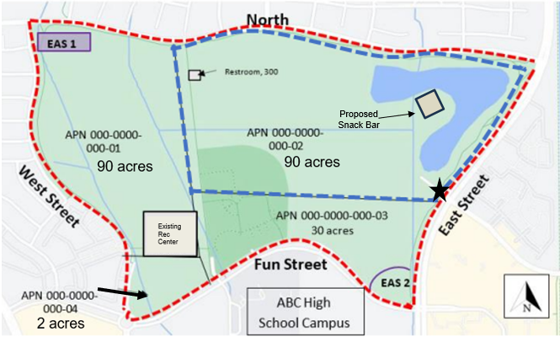
1 inch = .167th of a mile Map prepared on September 25, 2023
 | 212 total acres will be placed under LWCF protection in perpetuity.
 | 90 acres were placed under LWCF protection in 2015 because of Capitol Park Development project 06-01234
 | Entry Point for Park
 | Easement 1 = Public utilities easement*
 | Easement 2 = Public utilities easement*
*A full description of the scope and purpose of all easements and indoor structures is attached.

Adventure County Authorized Representative Date

CA Department of Parks and Recreation Date

This map is binding once signed by all parties. If there was a previous LWCF PROJECT(S) completed at the same PARK SITE, then the GRANTEE, OGALS, and NPS will review the LWCF BOUNDARY MAPS associated with the previous PROJECT(S) for consistency with the LWCF BOUNDARY MAP for the new LWCF PROJECT.

Note: Authority cited: Section 5099.10 Public Resources Code. Reference: Sections 5099- 5099.12, Public Resources Code, Public Law 88-578, 16 U.S.C. 460l – 6(f)(3)

Attachment for Sample Park, Adventure County, LWCF project number , in the county of Adventure County

Indoor Structures

Existing Recreation Center | - 2000 square feet  - Recreation center, restrooms, and fitness center  - No proposed expansions planned at this time.
Existing Restroom | - 300 square feet  - Restroom open to the public when the park is open.
Proposed Snack Bar | - 400 square feet  - Snack bar with restrooms.  - To be built as part of the project.

Other Rights and Interests

Easement 1 | - Public Utilities easement – Adventure County Water District sewer pipe access  - Size: 500 square feet (10 feet wide, 50 feet long)  - Use/purpose: For Water District access to maintain sewer lines for inspections and maintenance  - Restrictions: Can’t build on top of easement but easement area can be used by park visitors
Easement 2 | - Public Utilities Easement –Adventure County Water District Drainage basin  - Size: 1000 square feet (100 feet by 100 feet)  - Use/Purpose: Flood protection for park  - Restrictions: None

